**Week 8**

**Git Hands-On Lab 1 – Basic Git Operations and Repository Management  
  
Step 1: Setup your machine with Git Configuration**

**git --version**

**git config --global user.name "rajapandiyants"**

**git config --global user.email "rajapandiyants@gmail.com"**

**git config –list**

**Step 2: Integrate notepad++.exe to Git and make it a default editor**

**notepad++**  
**git config --global core.editor "\"C:/Program Files (x86)/Notepad++/notepad++.exe\" -multiInst -nosession"  
  
  
Step 3: Add a file to source code repository**

**cd ~**

**mkdir GitDemo**

**cd GitDemo**

**git init  
  
echo "Welcome to Git Hands-On Lab" > welcome.txt**

**ls**

**cat welcome.txt  
  
git status**

**git add welcome.txt**

**git commit**

**git remote add origin https://github.com/rajapandiyants/GItDemo1.git**

**git pull origin master**

**git push origin master  
  
  
Output:**

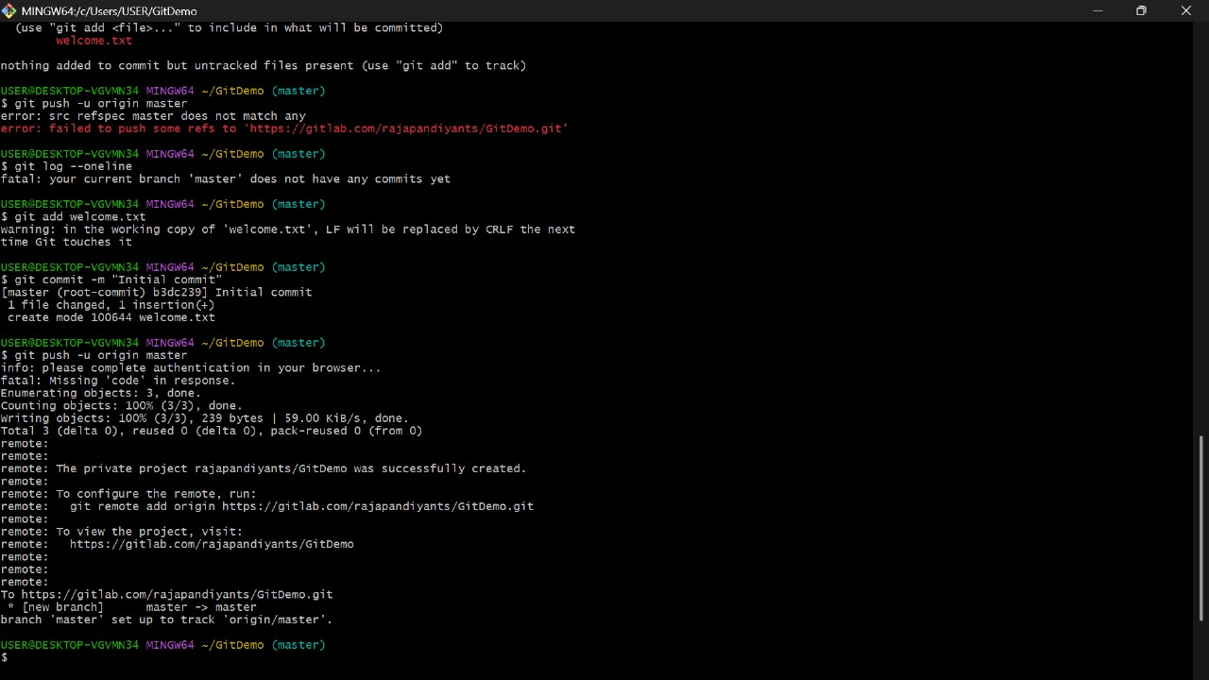

**Git Hands-On Lab 2 – Git Ignore  
  
Step 1: Create Unwanted Files  
  
touch debug.log**

**mkdir log**

**touch log/system.log**

**Step 2: Create .gitignore File  
  
touch .gitignore  
  
Add:  
  
*.log**

**log/  
  
Step 3: Check Git Status  
  
git status  
  
Step 4: Commit and Push  
  
git add .gitignore**

**git commit -m "Added .gitignore to ignore .log files and log folder"**

**git push origin master  
  
Output:**

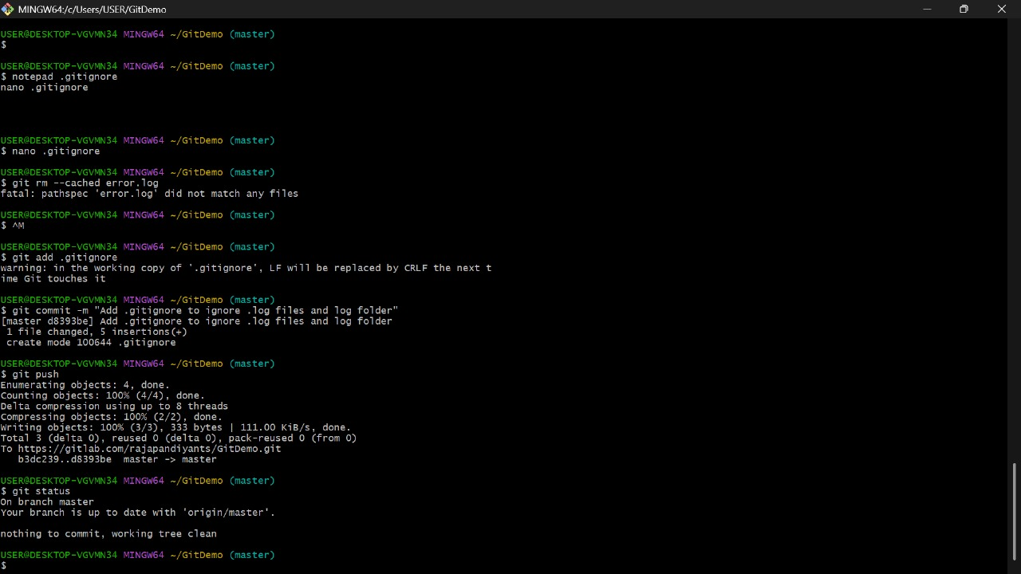

**Git Hands-On Lab 3 – Branching and Merging  
  
1. Created New Branch  
  
git checkout -b GitNewBranch  
  
2. Listed Branches  
  
git branch -a  
  
3. Created a File and Committed  
  
echo "This is from GitNewBranch" > branchfile.txt**

**git add branchfile.txt**

**git commit -m "Added branchfile.txt in GitNewBranch"  
  
4. Switched Back  
  
git checkout master**

**git diff master..GitNewBranch  
  
5. Merged**

**git merge GitNewBranch  
  
6. Checked Logs  
  
git log --oneline --graph –decorate  
  
7. Deleted Branch and Pushed  
  
git branch -d GitNewBranch**

**git push origin master  
  
Output:**

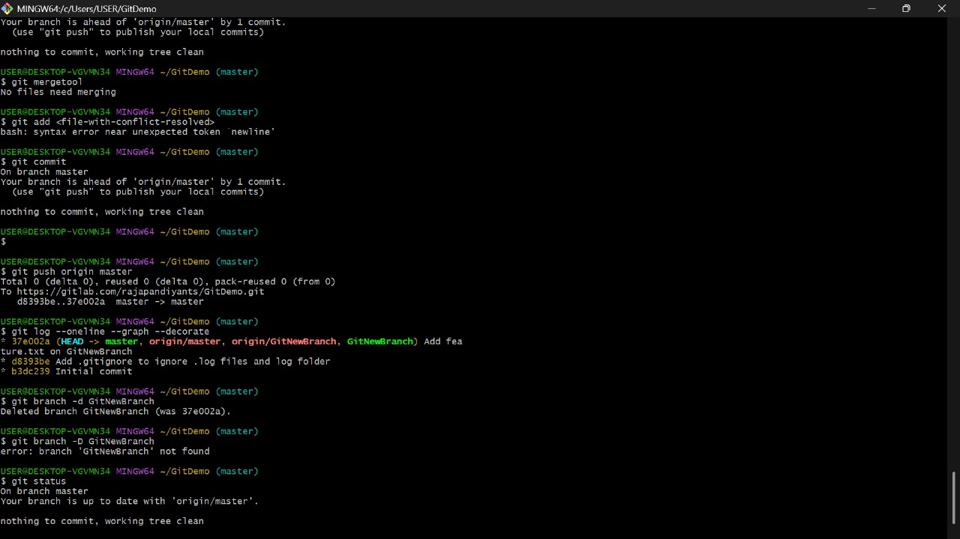

**Git Hands-On Lab 4 – Git Merge Conflict Resolution  
  
1. Created a branch GitWork  
  
git checkout -b GitWork  
  
2. Added hello.xml with unique content in GitWork  
  
echo "<message>Hello from GitWork</message>" > hello.xml**

**git add hello.xml**

**git commit -m "Added hello.xml in GitWork branch"  
  
3. Switched to master and created conflicting file  
  
git checkout master**

**echo "<message>Hello from master branch</message>" > hello.xml**

**git add hello.xml**

**git commit -m "Added hello.xml in master with different content"  
  
4. Merged and got conflict  
  
git merge GitWork  
  
5. Resolved conflict manually and committed  
  
git add hello.xml**

**git commit -m "Resolved merge conflict in hello.xml"  
  
6. Updated .gitignore and cleaned up  
  
echo "*~" >> .gitignore**

**git add .gitignore**

**git commit -m "Updated .gitignore to ignore backup files"  
  
7. Deleted merged branch  
  
git branch -d GitWork  
  
8. View the final graph  
  
git log --oneline --graph --decorate  
  
Output:**

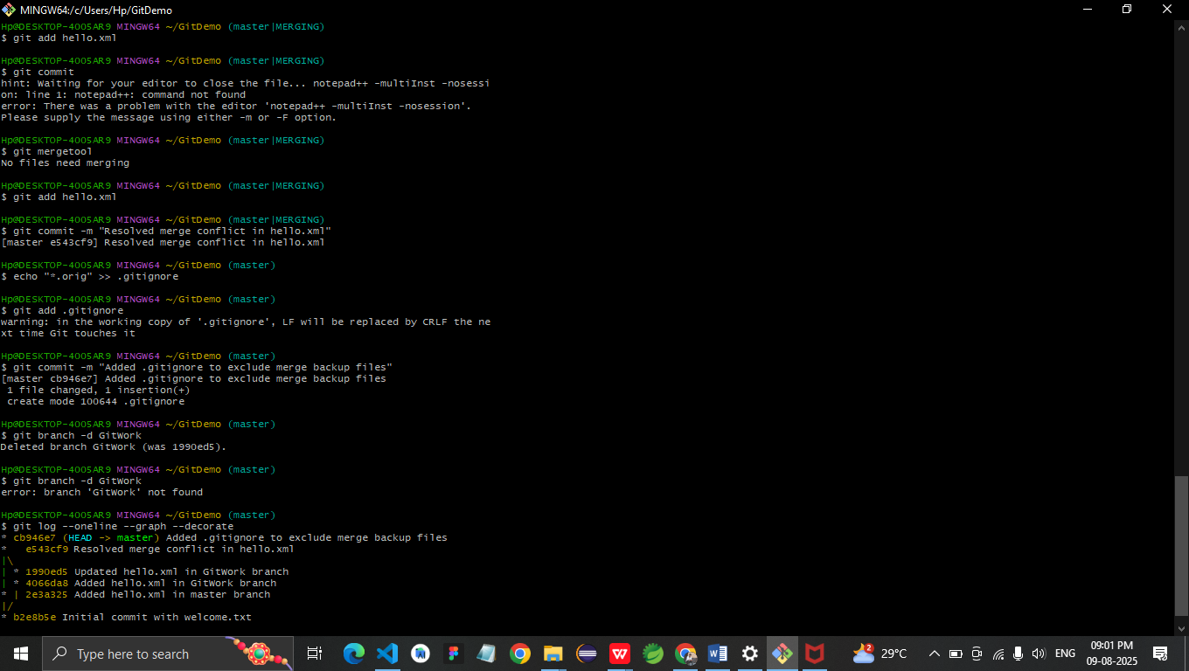

**Git Hands-On Lab 5 – Git Cleanup & Push Lab  
  
1. Switched to master branch  
  
git checkout master  
  
2. Checked git status  
  
git status  
  
3. Listed all branches  
  
git branch -a**

**4. Pulled latest changes  
  
git pull origin master  
  
5. Pushed pending changes  
  
git push origin master  
  
6. Verified updates in GitLab repo  
  
Visited:  
https://github.com/rajapandiyants/GItDemo1.git**

**Output:**

